**SPRINT-1**

**Group 7:**

**Aakanksha**

**Anshika Gupta**

**Jahnavi Sagiraju**

**Prakhar Srivastava**

**Yash Thakur**

Links:

Dataset 1 (A, B, C): <https://colab.research.google.com/drive/178zuPC3HU4-jfiC-tPBkIrOrP15AaypR>

Dataset 1 (D, E):

<https://colab.research.google.com/drive/1O7p15l4r7dvfPUTKuI7Yi2LYM1owWip_?usp=sharing>

Dataset 2 Tableau: <https://public.tableau.com/app/profile/yash.thakur7671>

Profile Report: <https://github.com/aakanksha-a/AI_aasignment/blob/main/output%20(1).html>

**DATASET 1:**

1. Correlation Heat Map of Key Variables

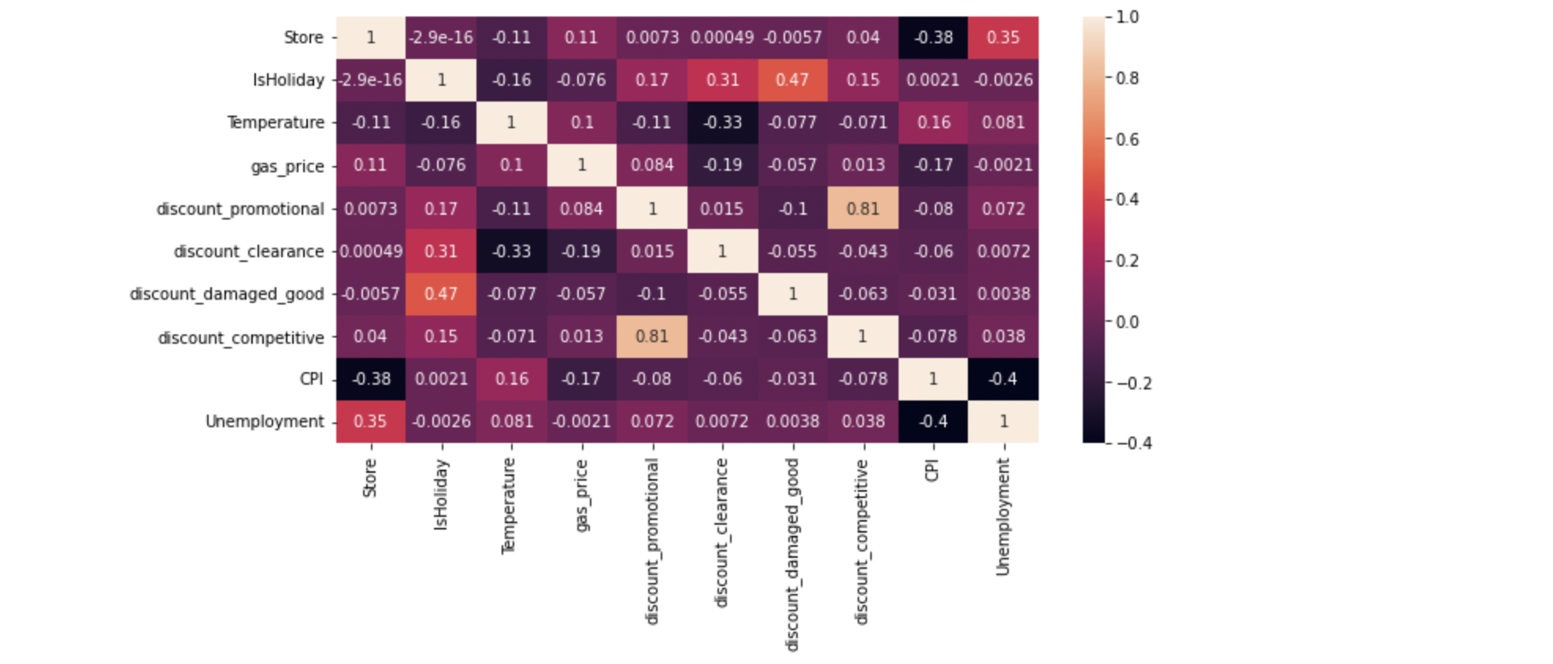

Store vs Weekly Sales: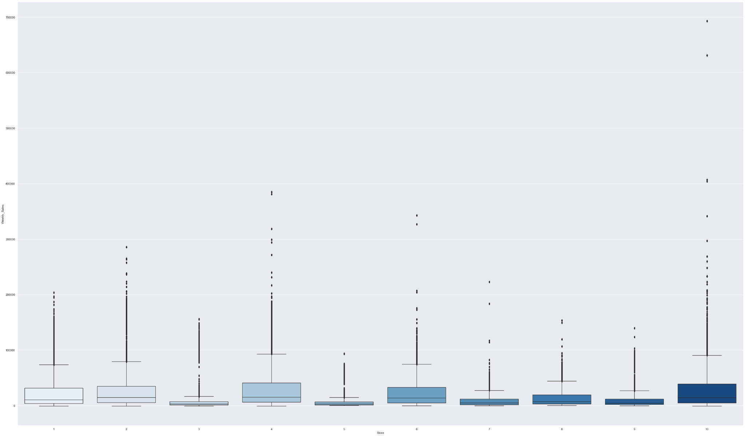

Department vs Weekly sales: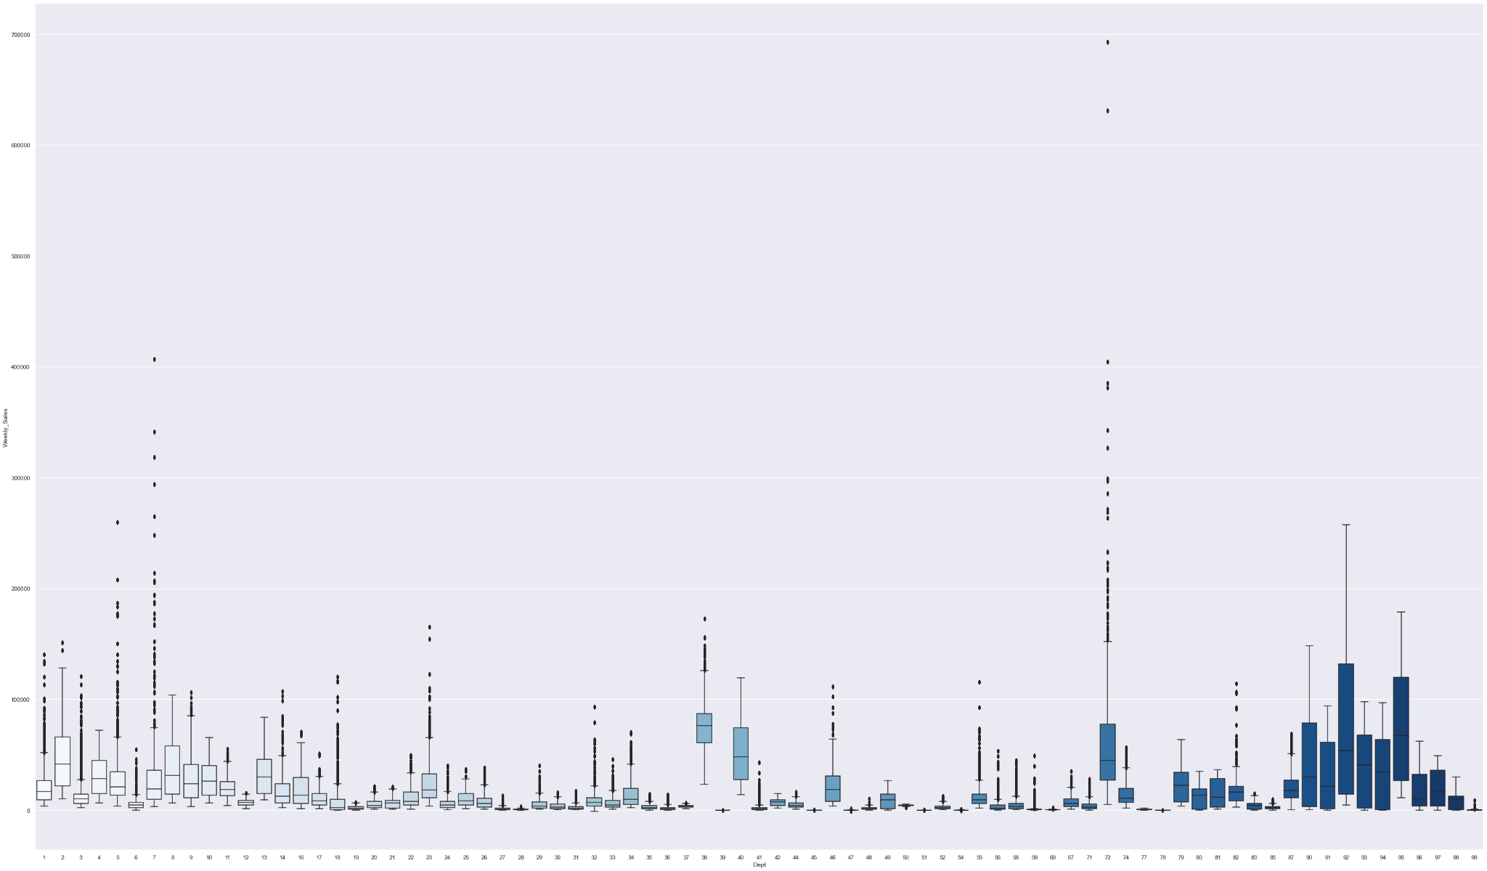

B) Weekly and Monthly sales patterns:

-weekly sales over department: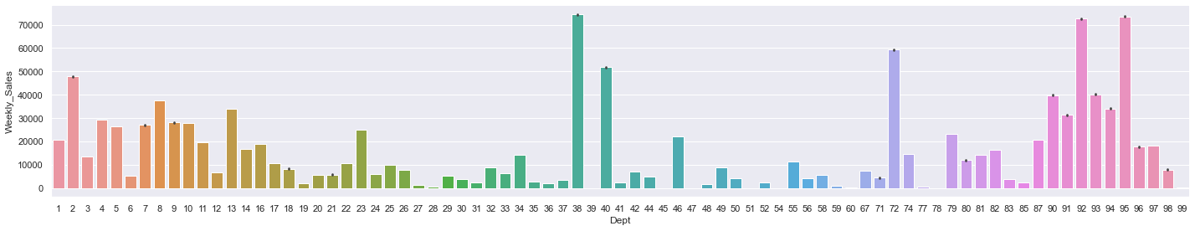

B.1) Department 38 has the highest weekly sales for the first 10 stores.

-monthly sales over department:

We have computed the monthly sales department wise. We constructed a separate dataframe by filtering out weekly sales based on each month’s sales.

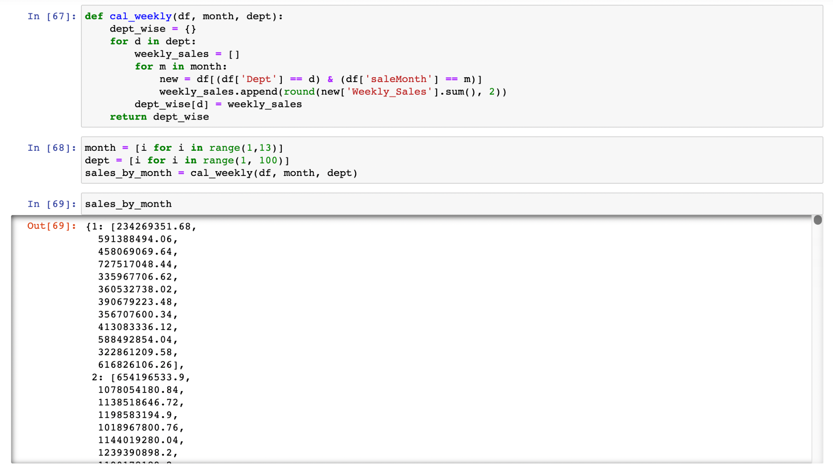

Jan: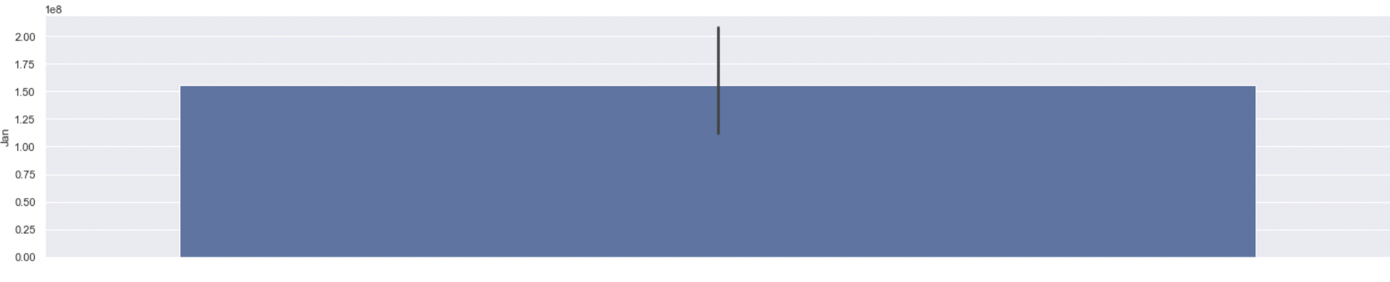Feb:

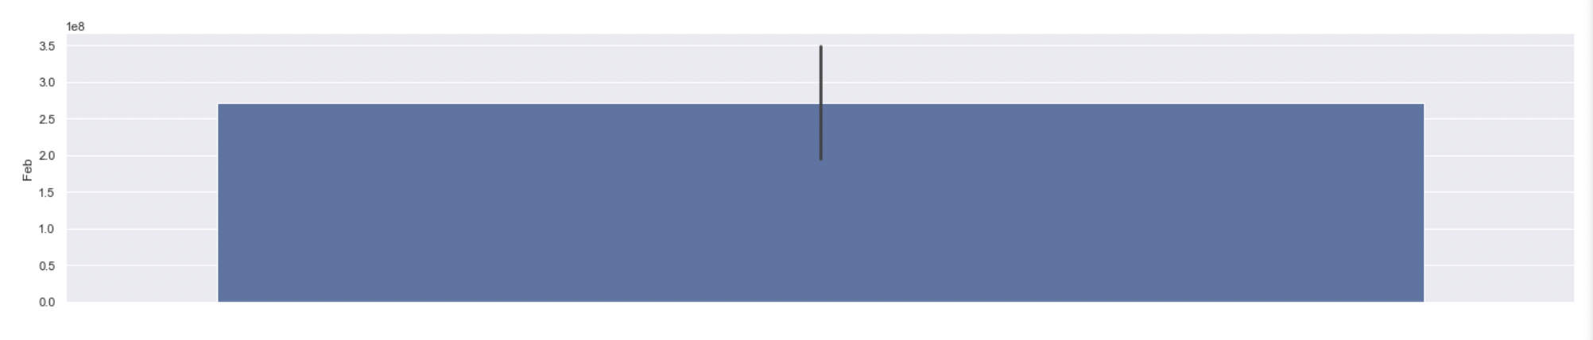

Mar: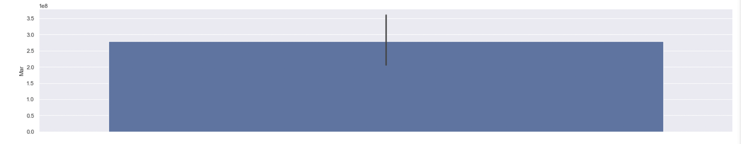

Apr:

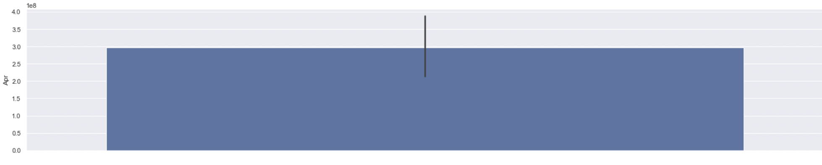

May: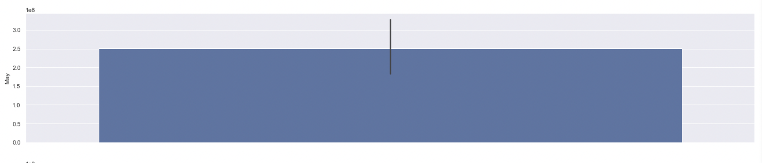

Jun: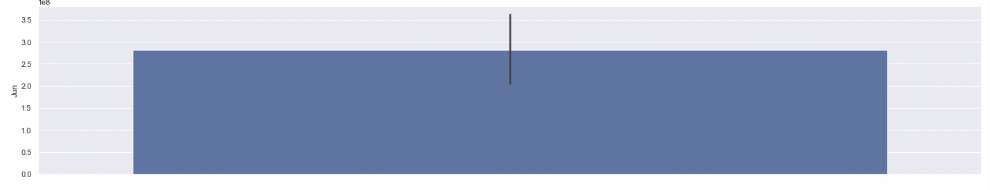

July: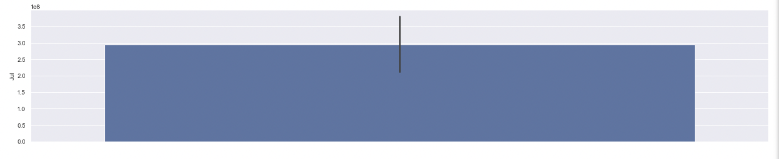

Aug: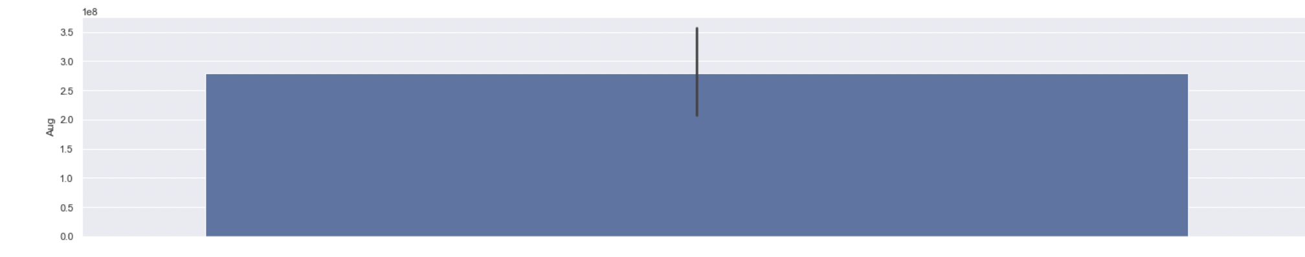Sept: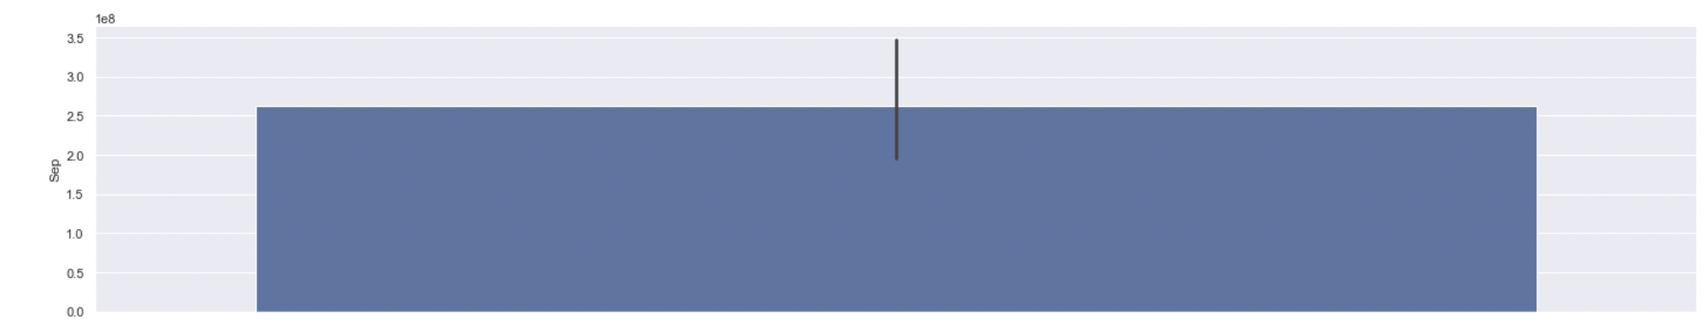

Oct: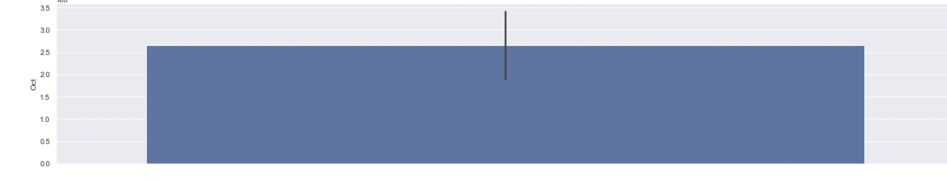Nov: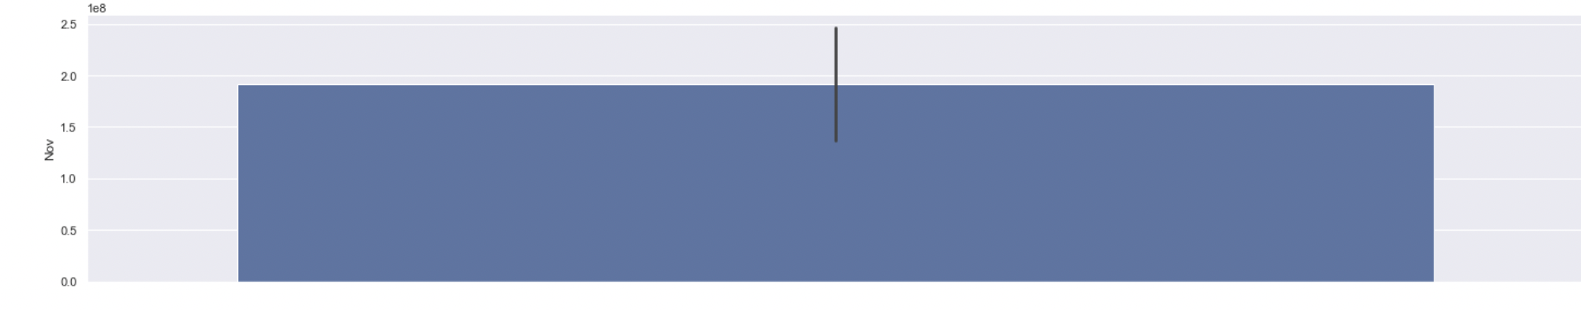

Dec: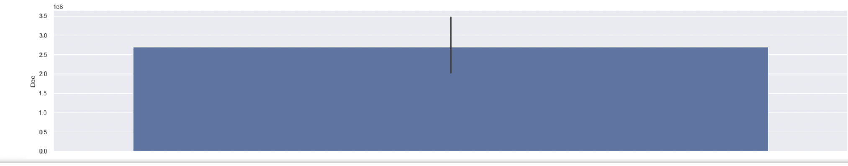

C) Relationship between weekly sales over CPI and unemployment:

-weekly sales over unemployment:



If unemployment has increased, sales have gone down.

If unemployment has decreased, sales have gone up.

Therefore, the relationship between weekly sales and unemployment is inversely proportional.

-weekly sales over CPI:

If CPI increases, weekly sales increases.

If CPI decreases, weekly sales decreases.

Therefore, the relationship between weekly sales and CPI is directly proportional.

Weekly sales vs store:

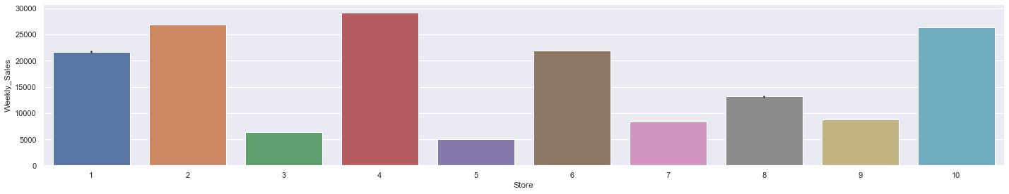

D) Impact of types of discounts:

-Discount Damaged Goods vs Store: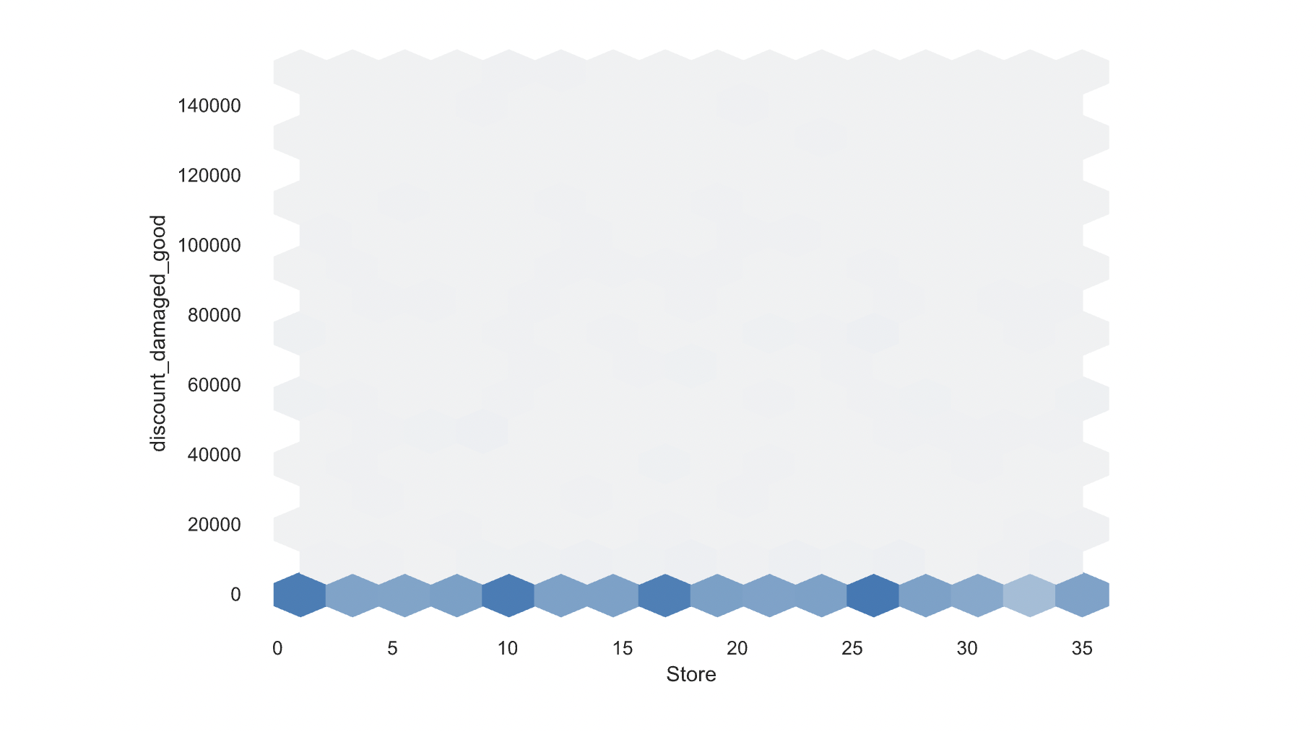

-Promotional discount vs Store: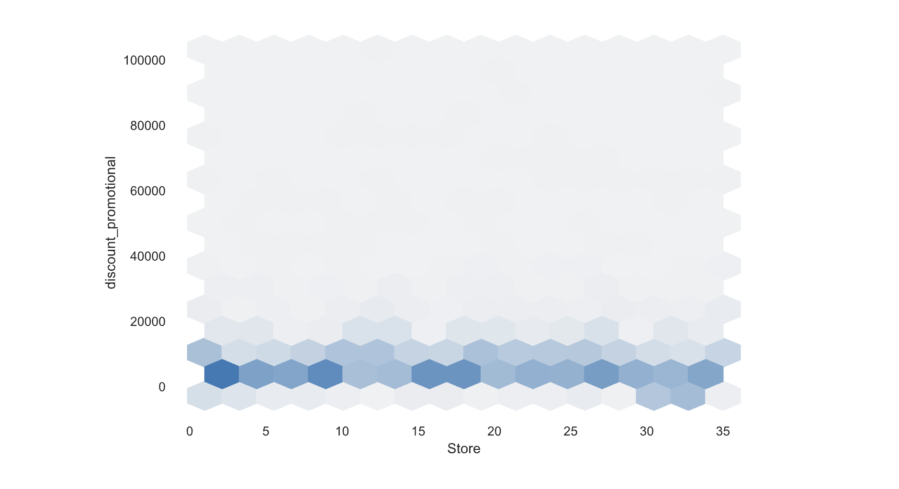

Weekly sales vs Competitive discount: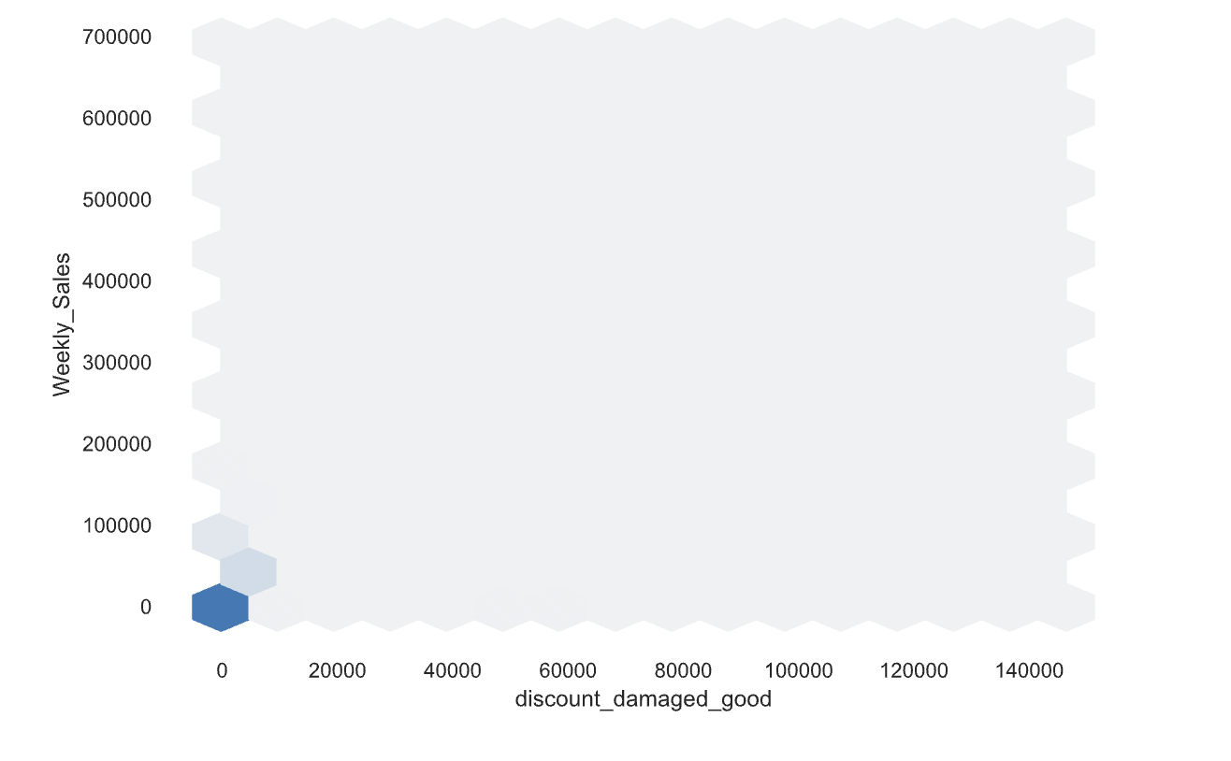

Weekly Sales vs Discount Clearance: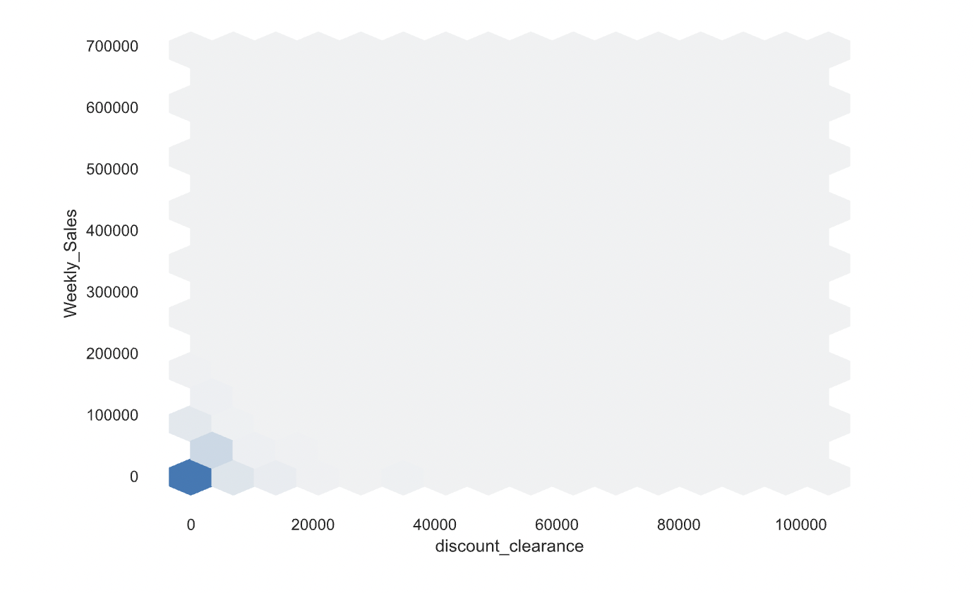Weekly sales vs promotional discount: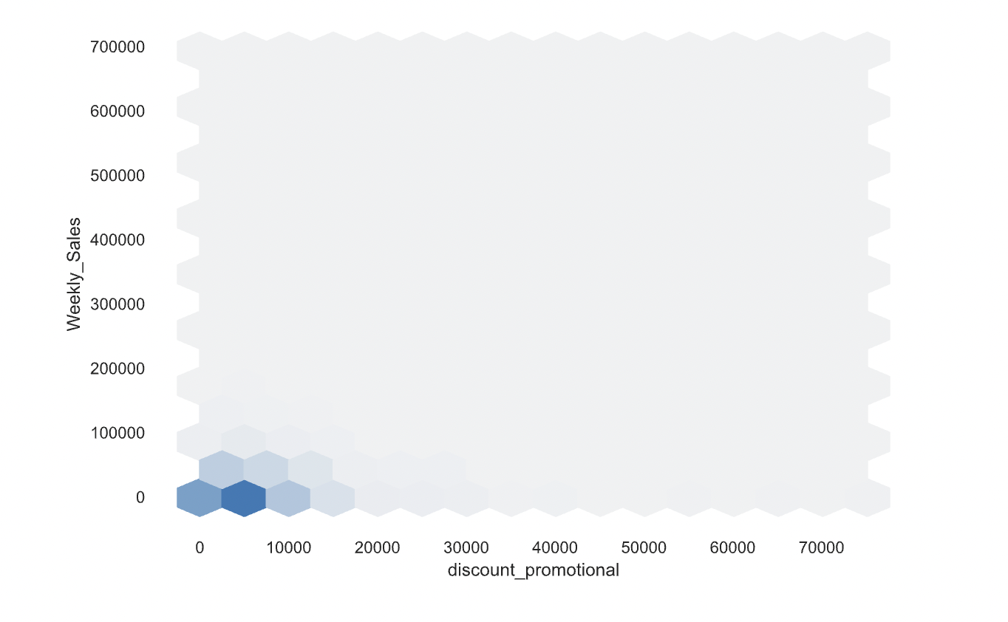

Promotional Discount vs Store:



Competitive discount vs store: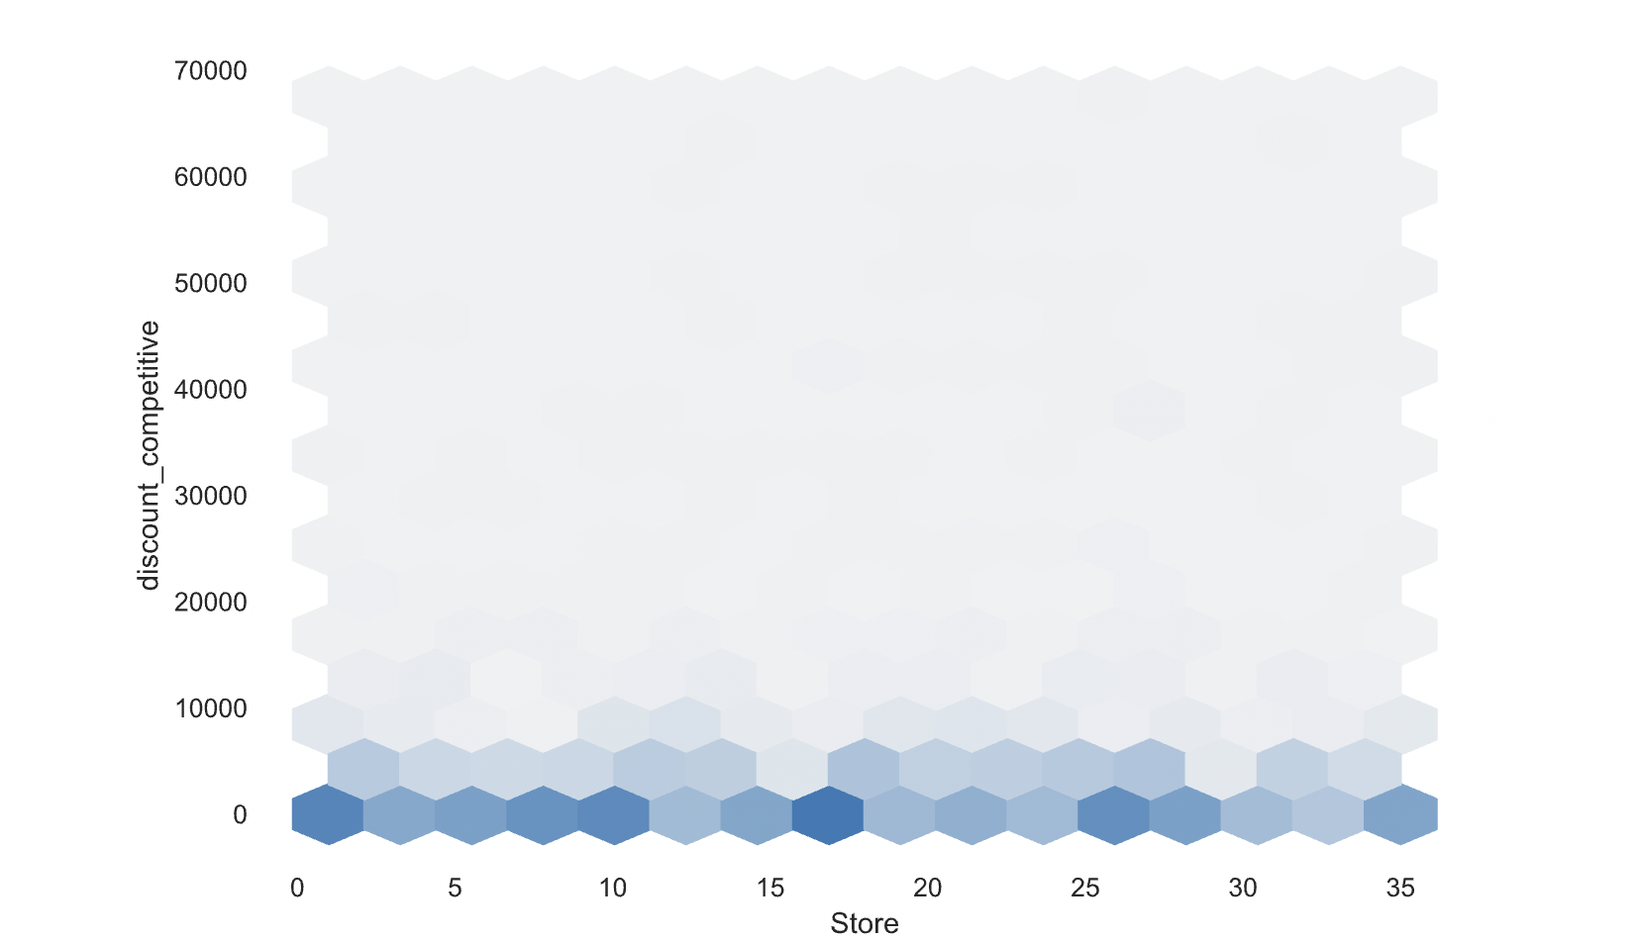

D.1) Based on the above graph, we deduct that promotional discount helps increase sales. It also has the stronger impact compared to the rest.

D.2) Yes, the observed behavior holds true for all stores.

E) Impact from external factors: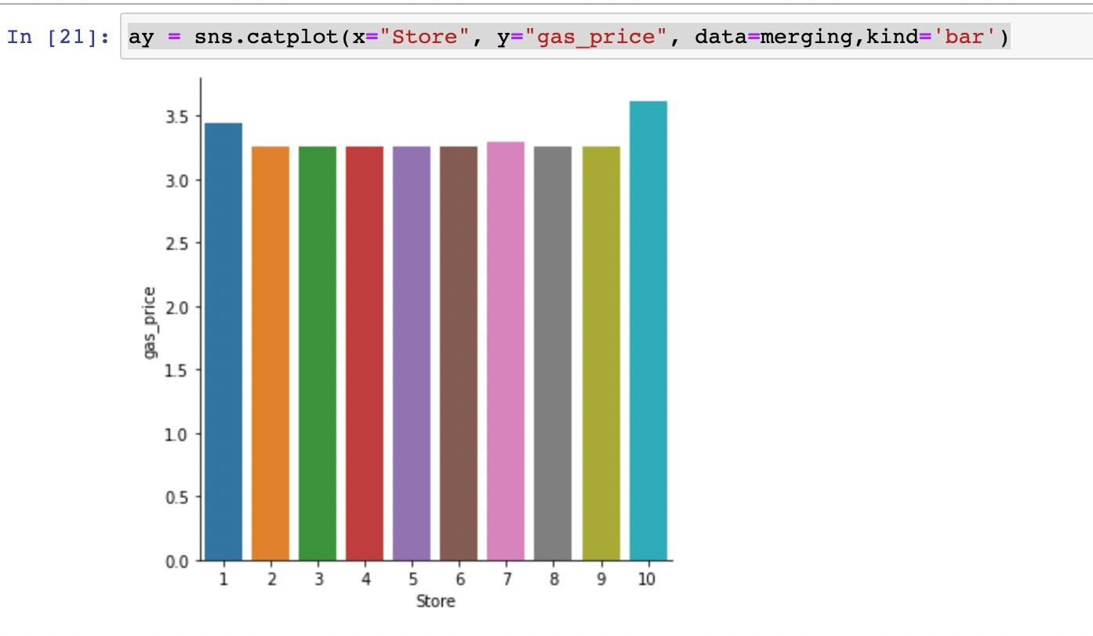

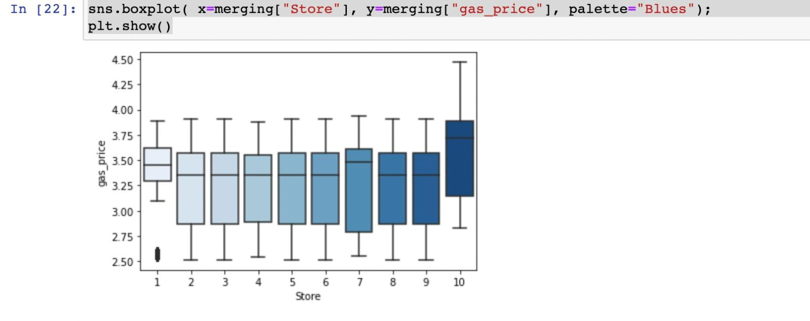Based on the above graphs, store 10 (type B) is most impacted by temperature.

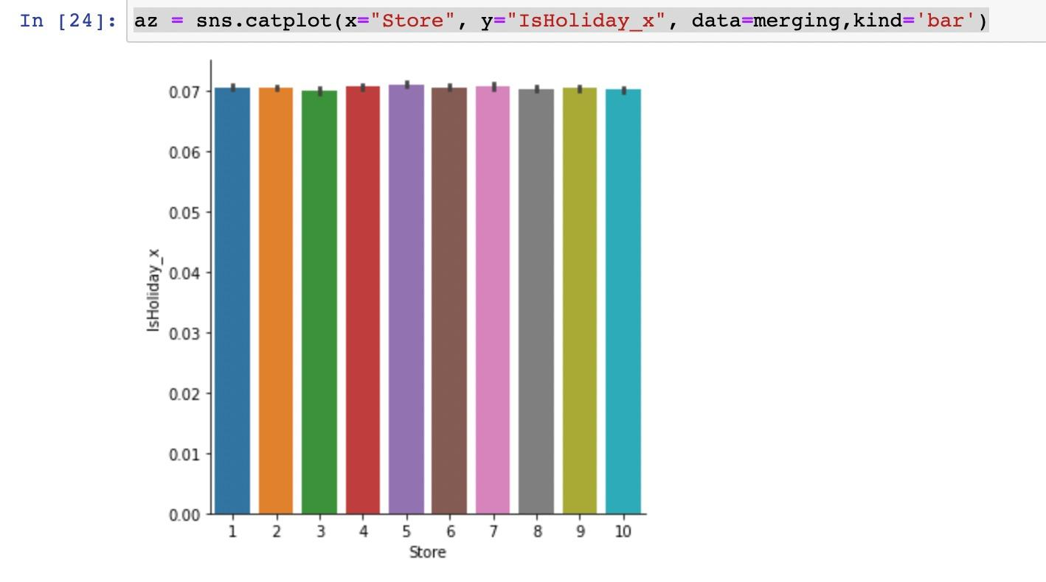

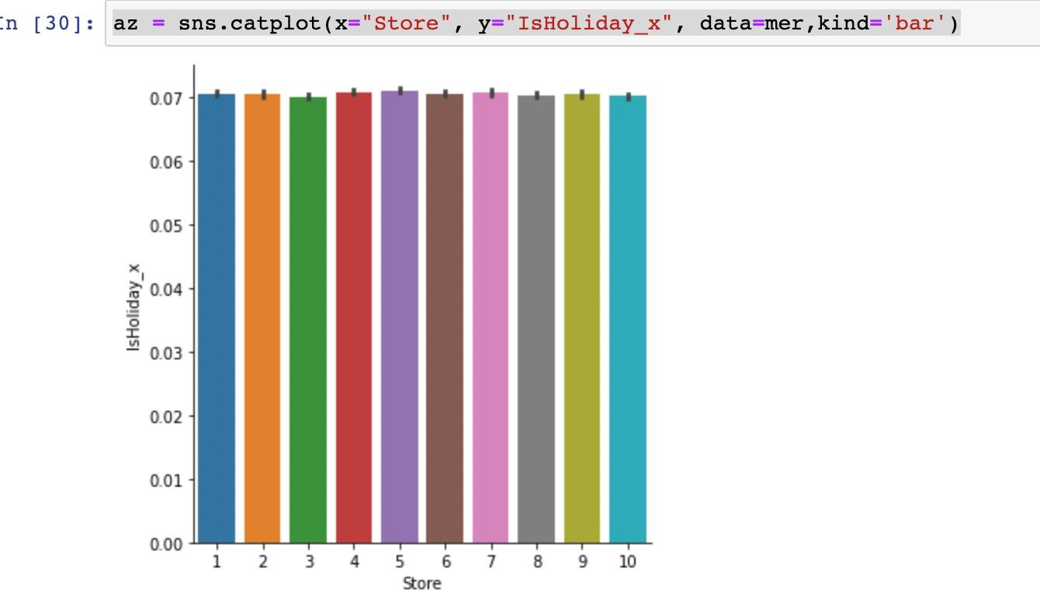

Based on the graphs above, there is not much correlation between weekly sales and holidays because the impact is almost the same for all stores.

**DATASET 2:**

https://public.tableau.com/app/profile/yash.thakur7671

